**TRIP PLANNER**

Software Design Document

IEEE Std 1016 2009

Niladri Sekhar Bala

Nawaz Sk

Deepanjan Mitra

Shayan Maity

Dated: 01/05/2019

**TABLE OF CONTENTS**

**1. INTRODUCTION**

1.1 Purpose

1.2 Scope

1.3 Overview

1.4 Reference Material

1.5 Definitions and Acronyms

**2. SYSTEM OVERVIEW**

**3. SYSTEM ARCHITECTURE**

3.1 Architectural Design

3.2 Decomposition Description

3.3 Design Rationale

**4. DATA DESIGN**

4.1 Data Description

4.2 Data Dictionary

**5. COMPONENT DESIGN**

**6. HUMAN INTERFACE DESIGN**

6.1 Overview of User Interface

6.2 Screen Images

6.3 Screen Objects and Actions

**7. REQUIREMENTS MATRIX**

**8. APPENDICES**

**1. INTRODUCTION**

**1.1 Purpose**

Identify the purpose of this SDD and its intended audience. (e.g. “This software

design document describes the architecture and system design of XX. ….”).

**1.2 Scope**

Provide a description and scope of the software and explain the goals, objectives and

benefits of your project. This will provide the basis for the brief description of your

product.

**1.3 Overview**

Provide an overview of this document and its organization.

**1.4 Reference Material**

List any documents, if any, which were used as sources of information for the test plan.

**1.5 Definitions and Acronyms**

Provide definitions of all terms, acronyms, and abbreviations that might exist to

properly interpret the SDD. These definitions should be items used in the SDD that

are most likely not known to the audience.

**2. SYSTEM OVERVIEW**

Give a general description of the functionality, context and design of your project.

Provide any background information if necessary.

**3. SYSTEM ARCHITECTURE**

**3.1 Architectural Design**

Develop a modular program structure and explain the relationships between the

modules to achieve the complete functionality of the system. This is a high level

overview of how responsibilities of the system were partitioned and then assigned to

subsystems. Identify each high level subsystem and the roles or responsibilities

assigned to it. Describe how these subsystems collaborate with each other in order to

achieve the desired functionality. Don’t go into too much detail about the individual

subsystems. The main purpose is to gain a general understanding of how and why

the system was decomposed, and how the individual parts work together. Provide a

diagram showing the major subsystems and data repositories and their

interconnections. Describe the diagram if required.

**3.2 Decomposition Description**

Provide a decomposition of the subsystems in the architectural design. Supplement

with textas needed. You may choose to give a functional description or an object

orienteddescription.

For a functional description, put top level data flow diagram (DFD) and structural

decomposition diagrams.

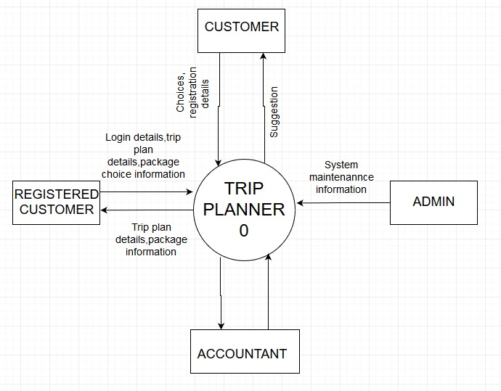

Context Diagram

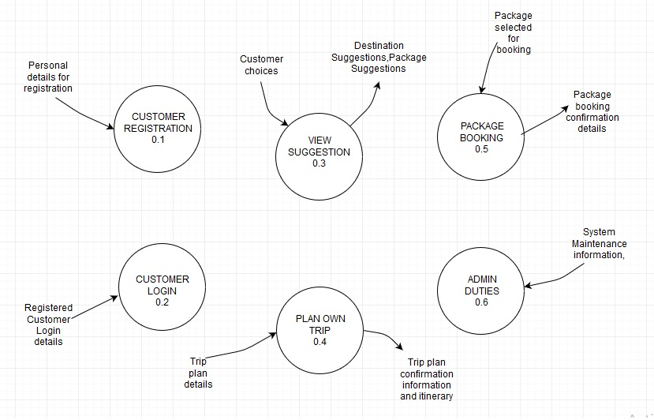

Level 1 Diagram

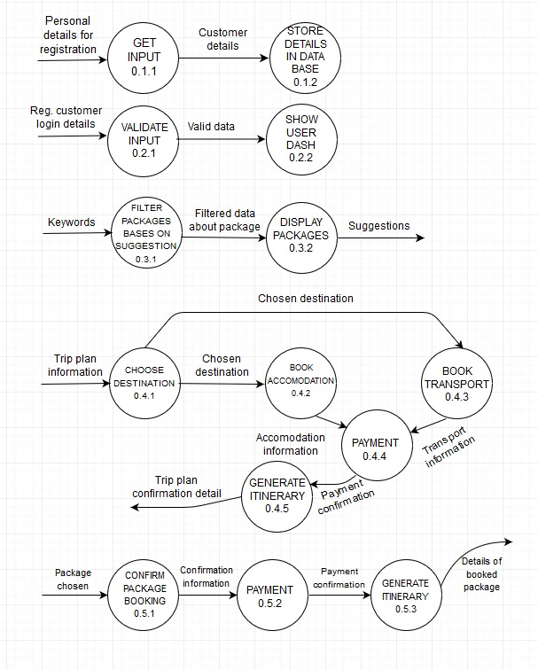

Level 2 Diagram

For an OO description, put subsystem model, object diagrams, generalization

hierarchy diagram(s) (if any), aggregation hierarchy diagram(s) (if any), interface

specifications, and sequence diagrams here.

**3.3 Design Rationale**

Discuss the rationale for selecting the architecture described in 3.1 including critical

issues and trade/offs that was considered. You may discuss other architectures that

were considered, provided that you explain why you didn’t choose them.

**4. DATA DESIGN**

**4.1 Data Description**

Explain how the information domain of your system is transformed into data

structures. Describe how the major data or system entities are stored, processed and

organized. List any databases or data storage items.

**4.2 Data Dictionary**

Alphabetically list the system entities or major data along with their types and

descriptions. If you provided a functional description in Section 3.2, list all the

functions and function parameters. If you provided an OO description, list the objects

and its attributes, methods and method parameters.

**registered_user table:**

|  |  |  |  |  |  |  |
| --- | --- | --- | --- | --- | --- | --- |
| Data item | Data type | Data format | Size for display | Description | Example | Validation |
| Email | String |  | 25 | Unique email of each user | abc@gmail  .com |  |
| Fname | String |  | 20 | Name of the user | Amit |  |
| Lname | String |  | 20 | Surname of the user | Sen |  |
| Street | String |  | 30 | Street name where user lived | M.k road |  |
| City | String |  | 20 | Name of the city where user lived | abcd |  |
| Pincode | Integer |  | 10 | Pincode of the location where user lived | 700036 |  |
| State | String |  | 20 | Name of the state where user lived | West bengal |  |
| Contact | Long Integer | NNNNNNNNNN | 10 | Mobile number of the user | 9866753478 |  |
| password | String |  | 20 | Password for login | Ab@01 | Containing upper case, lower case,number and special character |

**Package_info table:**

|  |  |  |  |  |  |  |
| --- | --- | --- | --- | --- | --- | --- |
| Data item | Data type | Data format | Size for display | Description | Example | Validation |
| PID | String | PPPPYYNNNN(package-number) | 10 | Unique ID of each package | MANA180023 |  |
| package _name | String |  | 20 | Name of the package | Manali trip |  |
| journey_date | Date | dd/mm/yyyy | 10 | Starting date of the journey | 12/08/2016 |  |
| Price | Long integer |  | 10 | Total package cost for each people | 25000 | price>0 |
| total_duration | Integer |  | 3 | Days required to complete the trip | 20 | total_duration>0 |

**Destination table:**

|  |  |  |  |  |  |  |
| --- | --- | --- | --- | --- | --- | --- |
| Data item | Data type | Data format | Size for display | Description | Example | Validation |
| destination_id | String | DDDDDDNNNN(detination-number) | 10 | Unique ID of each destination | MANALI0010 |  |
| Attractions | String |  | 30 | Name of the attracting places | Hadimba temple,  Kullu |  |
| Type | Array of String |  | 10 | Which type of place | Mountain  Adventurous |  |
| site_photos |  |  |  | Store attractive photos of the  site |  |  |

**trip_info table:**

|  |  |  |  |  |  |  |
| --- | --- | --- | --- | --- | --- | --- |
| Data item | Data type | Data format | Size for display | Description | Example | Validation |
| trip_id | String | MTTTTYYNNN(M-trip-number) | 10 | Unique ID of each trip | MMANA18001 |  |
| total_duration | Integer |  | 3 | Days required to complete the trip | 20 | total_duration>0 |
| start_date | Date | dd/mm/yyyy | 10 | Starting date of the trip | 12/08/2016 |  |
| Cost | Long integer |  | 10 | Total cost for the trip | 25000 |  |
| no_of_people | Integer | N | 4 | Number of people including user for trip | 5 |  |
| Email | String |  | 25 | foreign key references email of registered user table | abc@gmail.com |  |

**admin table:**

|  |  |  |  |  |  |  |
| --- | --- | --- | --- | --- | --- | --- |
| Data item | Data type | Data format | Size for display | Description | Example | Validation |
| Email | String |  | 25 | Email id of the admin | abc@gmail.com |  |
| Password | String |  | 20 | Password for login | Ab@01 | Containing upper case, lower case,number and special character |

**hotel table:**

|  |  |  |  |  |  |  |
| --- | --- | --- | --- | --- | --- | --- |
| Data item | Data type | Data format | Size for display | Description | Example | Validation |
| hotel_registration_no | String | CCSSPPNNNN(country-  state-city-number) | 10 | Unique registration number of each hotel | INWBKO1020 |  |
| hotel_name | String |  | 30 | Name of the hotel | Taj hotel |  |
| coordinates | Array of String |  | 8 | Coordinates of the hotel | 22.5612N  88.3512S |  |
| Rating | Float |  | 3 | Rate of hotel out of 5 | 3.5 | 0<=rating<=5.0 |
| Pincode | Integer |  | 10 | Pincode of the city where city belongs | 700036 |  |

**room table:**

|  |  |  |  |  |  |  |
| --- | --- | --- | --- | --- | --- | --- |
| Data item | Data type | Data format | Size for display | Description | Example | Validation |
| room_id | String | FFNNN  (floor-number) | 5 | Unique room id of each room of a hotel | 02202 |  |
| hotel _id | String | CCSSPPNNNN(country-  state-city-number) | 10 | foreign key references hotel_registration_no of hotel table | INWBKO1020 |  |
| rate_per_day | float |  | 8 | Rate per day for a room | 2000.00 |  |
| Details | String |  | 30 | Bed type,room attraction etc. | King or twin beds, Suite are perfect |  |
| room_type | String |  | 10 | Type of the room | Family Room |  |
| room_picture |  |  |  |  |  |  |

**Books table:**

|  |  |  |  |  |  |  |
| --- | --- | --- | --- | --- | --- | --- |
| Data item | Data type | Data format | Size for display | Description | Example | Validation |
| Email | String |  | 25 | foreign key references email of registered user table | abc@gmail.com |  |
| PID | String | PPPPYYNNNN(package-number) | 10 | foreign key references PID of package_info table | MANA180023 |  |
| no_of_people | Integer | N | 1 | Number of people including user for trip | 5 |  |
| payment-status | boolean |  | 3 | Indicate payment paid or not | Yes(successful)  no(unsuccessful) |  |
| booking_date | Date | dd/mm/yyyy | 10 | Booking date of the trip | 12/08/2016 |  |

**trip_details table:**

|  |  |  |  |  |  |  |
| --- | --- | --- | --- | --- | --- | --- |
| Data item | Data type | Data format | Size for display | Description | Example | Validation |
| trip_id | String | MTTTTYYNNN | 10 | foreign key references trip_id of trip table | MMANA18001 |  |
| destination_id | String | DDDDDDNNNN | 10 | foreign key references destination_idl of destination table | MANALI0010 |  |
| transport_details | String |  | 10 | During trip which transport is used by user | Train number:302756 |  |
| Duration | Integer |  | 3 | Duration of a trip in days | 20 |  |
| accommodation_details | String |  | 30 | Name of the hotels | Taj hotel,  Abc hotel,  Xyz hotel |  |

**package_details table:**

|  |  |  |  |  |  |  |
| --- | --- | --- | --- | --- | --- | --- |
| Data item | Data type | Data format | Size for display | Description | Example | Validation |
| destination_id | String | DDDDDDNNNN | 10 | foreign key references destination_idl of destination table | MANALI0010 |  |
| PID | String | PPPPYYNNNN(package-number) | 10 | foreign key references PID of package_info table | MANA180023 |  |
| transport_details | String |  | 10 | During trip which transport is used | Train number:302756 |  |
| Duration | Integer |  | 3 | Duration of the package in days | 20 | duration>0 |
| Important_places | String |  | 30 | Attractive places of the package | Kullu,Taj mahal |  |
| accommodation_details | String |  | 30 | Name of the hotels | Taj hotel,  Abc hotel,  Xyz hotel |  |

**5. COMPONENT DESIGN**

In this section, we take a closer look at what each component does in a more

systematic way. If you gave a functional description in section 3.2, provide a

summary of your algorithm for each function listed in 3.2 in procedural description

language (PDL) or pseudo code. If you gave an OO description, summarize each

object member function for all the objects listed in 3.2 in PDL or pseudocode.

Describe any local data when necessary.

**6. HUMAN INTERFACE DESIGN**

**6.1 Overview of User Interface**

Describe the functionality of the system from the user’s perspective. Explain how the

user will be able to use your system to complete all the expected features and the

feedback information that will be displayed for the user.

**6.2 Screen Images**

Display screenshots showing the interface from the user’s perspective. These can be

handdrawn or you can use an automated drawing tool. Just make them as accurate

as possible. (Graph paper works well.)

**6.3 Screen Objects and Actions**

A discussion of screen objects and actions associated with those objects.

**7. REQUIREMENTS MATRIX**

Provide a crossreference that traces components and data structures to the

requirements in your SRS document.

Use a tabular format to show which system components satisfy each of the functional

requirements from the SRS. Refer to the functional requirements by the

numbers/codes that you gave them in the SRS.

**8. APPENDICES**

Appendices may be included, either directly or by reference, to provide supporting details

that could aid in the understanding of the Software Design Document.